Cryomold Freezing & Embedding Protocol

1. Table of Contents

I. Table of Contents 1

II. Objectives 2

III. Overview 2

IV. Required Materials 2

V. Setup: 2

VI. Assay Procedure: Snap Freeze 3

VII. Appendix I: Safety Precautions & Disposal Instructions 7

1. Objectives
   1. Give a detailed explanation of the procedure for optimal freezing and embedding of histology blocks in OCT
   2. Describe appropriate storing conditions
   3. Describe common errors and how they can lead to artifacts
2. Overview
   1. Rapidly freeze tissue to preserve tissue structure
   2. Helpful link to a similar protocol with some background science behind vitreous ice formation – [Freezing Tissues For Histology](https://med.nyu.edu/research/scientific-cores-shared-resources/sites/default/files/nyu-expath-freezing-and-embedding-tissue.pdf)
3. Required Materials
   1. Tissue-Tek® O.C.T. Compound (VWR, SKU#: [25608-930](https://us.vwr.com/store/product?keyword=25608-930))
   2. Tissue-Tek® Cryomolds (Fisher Scientific, SKU#: [NC9806558](https://www.fishersci.com/shop/products/crymld-10x10x5mm-100-pk/NC9806558))
   3. Aluminum foil
      1. Cut into strips (~4.5” x 2.5”)
   4. #5 or #3 forceps for retrieving tissue from tubes
   5. Toothed tissue forceps
   6. Reverse action forceps (a.k.a. “self-closing” forceps)
   7. Razor Blade (VWR, SKU#: [55411-050](https://us.vwr.com/store/product/4548306/null))
   8. Liquid Nitrogen
   9. Isopentane (2-Methybutane) (Sigma-Aldrich, SKU#: [M32631-4L](https://www.sigmaaldrich.com/US/en/product/sigald/m32631))
   10. 1-2x Lab Coolers or 1 Cooler + 1 Nalgene® LN2 Dewar-Flask for LN2 (VWR, SKU#: [63380-052](https://us.vwr.com/store/product/4640086/null))
       1. One will serve as a side reservoir – see Setup, Step E
   11. 2x Lab Coolers for dry ice
   12. Polypropylene Tri-Corner Beaker, 400mL (for the 2-Methybutane) (Fisher Scientific, SKU#: [14-955-111D](https://www.fishersci.com/shop/products/tri-cornered-polypropylene-beakers-5/14955111D))
   13. Cryogenic Gloves
4. Setup:
   1. Cover benchtop with an underpad.
   2. Label all cryomolds with hashcode and region.
   3. Label all aluminum foil wrappings with hashcode, region, and date.
   4. Fill two ice coolers with dry ice – one will hold the samples and frozen cryomolds afterwards, the other will hold the cutting block, weigh boat, and sample being actively cut for a mold.
   5. Pull samples from -80°C freezer and place on dry ice.
   6. An example image of a past embedding setup can be viewed below:

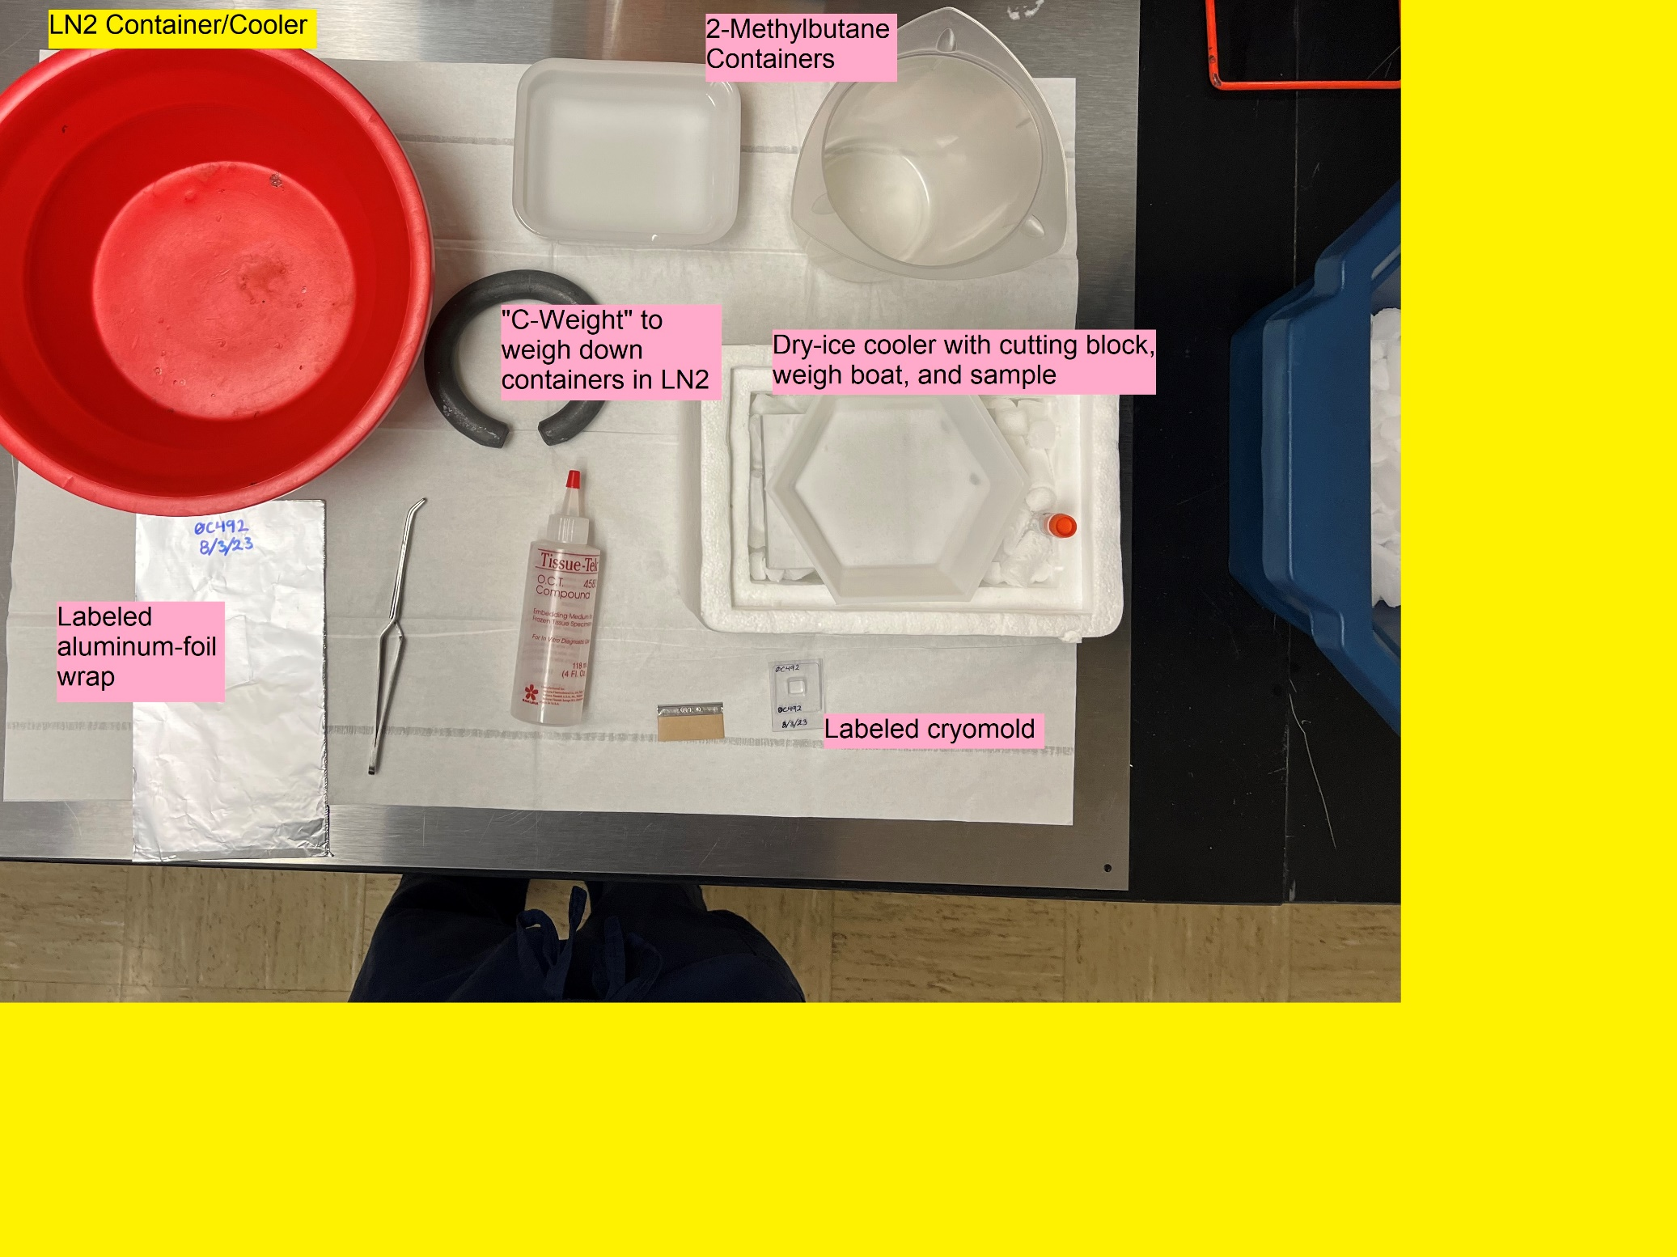

1. Assay Procedure: Snap Freeze
   1. Preliminary Steps:
      1. Pre-fill the labeled cryomolds about halfway with O.C.T. Compound and set to side.
      2. Place the cutting block in the dry ice cooler to bring it to temp. Place a large hexagonal weigh boat on top of the cutting block and set that cooler onto the underpad – this will be the “cutting station”.
      3. PUT ON CRYOGENIC GLOVES, then fill an ice cooler with LN2 until it is about half full.
         1. NOTE: be careful not to overfill. The LN2 level should be low enough that it will not boil into the 2-methylbutane container once the warmer container is introduced into the LN2.
         2. Depending on how many samples need to be embedded, fill a second ice cooler or Nalgene® LN2 Dewar-Flask with LN2 (this will serve as a quickly accessible LN2 reserve to refill the primary cooler. LN2 will be rapidly evaporating throughout this process, especially when the room-temp 2-methylbutane container is introduced).
      4. Fill 2-methybutane container (i.e., the tri-corner beaker, ceramic rectangular container, or an aluminum can [not pictured above]) with ~200-300mL of 2-methylbutane.
      5. Begin slowly submerging the 2-methylbutane container to bring it down to snap-freezing temperature (-200°C). You made need a large pair of hemostats, a clamp wrench, or some other tool that will let you lower the container at a measured pace without freezing your hands off.
         1. NOTE: a lot of the LN2 will boil off as the 2-methybutane cools. This can be quickly replenished from the LN2 reserve if needed.
      6. After a few minutes, the LN2 boiling will slow to a simmer and the 2-methylbutane container will be getting frosty. Once you notice this, leave it in for another minute to make sure the 2-methylbutane is adequately cooled, then remove the 2-methylbutane container and set it to the side while you cut the first sample.
         1. If you leave the container in liquid nitrogen for too long, the 2-methylbutane will freeze solid and make it impossible to submerge the cryomolds until it thaws back out.
   2. Procedure:
      1. Grab the first sample tube, pull out/cut off a chunk of tissue, and place it in the cold weigh boat at the “cutting station”. Place the tube with tissue on dry ice while you cut.
      2. Trim down the tissue chunk to fit into the cryomold while keeping it cold on the dry ice. The tissue should take up around half of the volume in the cryomold well, unless you are targeting a specific tissue type/region (e.g., pectinate muscles).
         1. NOTE: It can be helpful for cryosectioning if the tissue chunk is cut into a relatively cubic shape so that the sides are all somewhat flat and even.
      3. Once finished cutting the tissue chunk, leave it on the dry ice while you put the rest of the tissue back into the sample tube.
      4. At this point, you can choose to continue all the way through one sample at a time, or you can set the tissue chunks to the side (keep on dry ice, and make sure there is some way to identify the tissue so you aren’t mixing up samples.)
      5. Once all your samples are cut and ready, submerge the 2-methylbutane back into the LN2 bucket/cooler to cool it down.
      6. Wait until the LN2 boiling slows to a simmer before moving on.
      7. Once the 2-methylbutane is cool enough, take one sample at a time, quickly put it into its respective, pre-labeled cryomold, push the sample down into the OCT, cover the sample with more OCT on top so the tissue is completely immersed in the OCT (try to avoid introducing bubbles into the OCT while pouring as these can affect cutting later), grab the reverse action forceps and clamp the edge of the cryomold, then submerge in the 2-methybutane for 15-20 seconds.
         1. NOTE: this step all needs to be done as a single, swift, contiguous process. Do not give the sample time to thaw while covering it with the room temperature OCT or it will likely lead to tissue damage that will interfere with staining later.
      8. After the sample has been flash frozen, quickly wrap the entire mold in aluminum foil and place on dry ice. The aluminum foil should be labeled with hashcode, region, and the current date.
      9. Once all of the cryomolds have been made up, store them in the -80°C freezer or a liquid nitrogen dewar. Do not store cryomolds at anything warmer than -80°C.
         1. NOTE: if samples are stored in a -20°C freezer, for example, the block will be warm enough to allow the ice to slowly reorganize itself into lattice structures. These lattices will tear through cellular structures and basically mangle the tissue on a molecular level, hence why it’s important to “flash-” or “snap-freeze” the tissue, locking the water molecules into place before they have time to form lattices within the tissue.
2. Appendix I: Safety Precautions & Disposal Instructions
   1. Safety Information for LN2
      1. Handle with extreme caution to avoid frostbite.
      2. Use the cryogenic safety gloves while handling any container filled with LN2 or when handling anything that has been in the LN2.
      3. Disposal: set containers with leftover LN2 in a safe and out-of-the-way area, then allow to evaporate.
   2. Safety Information for 2-Methylbutane
      1. Flammable
      2. Allow to evaporate after use.
   3. General Safety Best Practices
      1. Wear proper PPE, including eye protection, in case the frozen tissue shatters while it is being cut.
      2. Razor blades are extremely sharp! Keep blade pointing away from yourself and other persons at all times.